Formal Notice of the 2025 Annual General Meeting
In accordance with our Rules of Association (Rules), the 2025 Annual General Meeting (AGM) of JOY Melbourne Inc. (trading as JOY Media) will be held as follows:
Date and Time: Monday 24 November 2025 at 6:30 pm AEDT
Venue: In Person at the Victorian Pride Centre Auditorium, Ground Level, 79-81 Fitzroy Street, St Kilda, and online via Zoom (the link will be provided before the meeting).
Agenda
1 | 6:30 pm | Welcome to the Meeting and Acknowledgement of Country  JOY Media acknowledges the Yaluk-ut Willam clan of the Boon Wurrung people of the Kulin Nation, the Traditional Owners of the land on which we meet and broadcast.  We pay our respects to their Elders past and present, and extend that respect to the Elders and allies of our diverse LGBTQIA+ communities. | President
2 | 6:32 pm | Apologies | President
3 | 6:35 pm | 2024 AGM Minutes | President
 |  | MOTION: That the 2024 AGM Minutes be accepted.
4 | 6:40 pm | President’s Report | President
 |  | MOTION: That the President’s Report for 2025 be accepted.
5 | 6:50 pm | Treasurer’s Report | Treasurer
 |  | MOTION: That the Treasurer’s Report and the audited 2025 Financial Report be accepted.
6 | 7:00 pm | Chief Executive Officer’s (CEO’s) Report  MOTION: That the 2025 CEO Report be accepted. | CEO
7 | 7:15 pm | Announcement of Board Members automatically elected | President
- No election required; 3 nominations received for 5 vacant positions.
- Introduction of automatically elected Board members; note that office bearers for 2025–26 will be elected by the Board following the formal AGM proceedings.
- The Board will convene immediately following the formal AGM proceedings to appoint one additional member to fill a casual vacancy, ensuring the Board meets the minimum of six members required under the Rules.
8 | 7:30 pm | Meeting Close

JOY Community Celebration: Guest Speaker and JOY Awards
1 | 7:30 pm | Guest Speaker: To be advised
2 | 7:50 pm | Presentation: Addam Stobbs Award for Broadcasting Excellence | President
3 | 7:55 pm | Presentation: Volunteer of the Year Award | CEO
4 | 8:00 pm | Presentation: Life Memberships | President
5 | 8:05 pm | Presentation: President’s Award | President
6 | 8:10 pm | Announcement of Office Bearers | President
7 | 8:15 pm | Community Celebration Close
Attendance
All JOY Media members are welcome to attend the 2025 AGM. This year’s meeting will be held in person and online. Members will receive an email invitation to participate in person, join via Zoom, or send an apology.
If you have not received your invitation, please email secretary@joy.org.au with your name, member number and best contact phone number so we can resend it. You can also call JOY reception on 03 9267 6000 during business hours.
RSVPs close at 4:00 pm on Friday 21 November 2025. The Zoom link for the online meeting will be sent after the RSVP period closes.
If you need to change your attendance at short notice due to illness or other unforeseen reasons, please use the Zoom link that will be sent to all attendees.

Meeting Documents
All documents relating to the meeting can be downloaded at the AGM page on the JOY Media website.
The JOY Media 2024-25 Annual Report will be presented at the meeting. After the meeting, the Annual Report will be available on the JOY Media website here.
Election and Proxy Form
An election for board members is not required at this AGM, as there were five vacancies and three nominees. The number of nominations received was fewer than the number of vacancies. Therefore, the nominated candidates are declared elected unopposed.
For your information, the candidate statement for the three board members elected unopposed is attached to this document. Please make them welcome as JOY Board Members for the next three years.
The Board will comprise five members, one short of the required minimum of six. The five-member Board will meet immediately following the formal AGM proceedings to consider filling the casual vacancy under Rule 24.3 and to elect office bearers. The results will be announced at the end of the Community Celebration.
Proxy form for voting on motions can be downloaded from the AGM page on the JOY website.
Apologies may be provided to the Secretary no later than 24 hours before the commencement of the 2025 AGM by submitting the Proxy Form or by email to secretary@joy.org.au.

Minutes of the 2024 Annual General Meeting

DRAFT (To be confirmed at the 2025 AGM)
In accordance with JOY Melbourne Inc. Rules of Association, the Annual General Meeting (AGM) of JOY Melbourne Inc. was held as follows:
Date: Monday 25 November 2024
Time: 6:30 pm AEDT – meeting opened at 6:36 pm.
Location: The meeting was held as a hybrid event, both in person at the Victorian Pride Centre and online via Zoom.
Apologies: Tim Anderson, Lachlan Hickey, Leonore Ryan, Michael Kempton, Nadine Cohen, Tass Mousaferiadis.
Minute taker: John Wintle.

Record of meeting
1 | Welcome & Acknowledgement | Interim CEO: Con Keramitsis
JOY wishes to acknowledge the Yaluk-ut Willam clan of the Boon Wurrung people of the Kulin nation, on whose land we are gathered this evening, and from which JOY broadcasts.
We pay our respects to their Elders, past and present.
We also acknowledge and pay our respects to the Elders and allies of the diverse LGBTQIA+ communities.

2 | Apologies: See list above | President: Paul Horwell
3 | Acceptance of Minutes for 2023 Annual General Meeting | President: Paul Horwell
 | MOTION: That the 2023 JOY Melbourne Inc. Annual General Meeting Minutes be accepted.
 | Moved: | David Hunt
 | Seconded: | Ben Mountford
 |  | Carried
4 | President’s Report | President: Paul Horwell
 | MOTION: That the 2023—24 President’s Report be accepted  Moved: | Gary Wilson
 | Seconded: | Joe Ball
 |  | Carried

5 | Finance Report and Audited Financial Report |  | President: Paul Horwell
 | MOTION: That the Finance Report and associated Audited Financial Report for JOY Melbourne Inc. for the 2023—24 financial year be accepted.
 | Moved: |  | Andy MacNamara
 | Seconded: |  | Mark Zanin
 |  |  | Carried
6 | Chief Executive Officer’s Report |  | Interim CEO: Con Keramitsis
 | MOTION: That the 2023—24 CEO’s Report be accepted.  Moved: |  | Pete Holmes
 | Seconded: |  | Kermie Breydon
 |  |  | Carried
7 | Guest Speaker – Victorian Commissioner for LGBTIQA+ Communities, Joe Ball
8 | Board Positions |  | President: Paul Horwell
 | There were no current board members whose terms were ending at the end of the meeting. There was one additional vacancy.
There was one nominee for the one position, so Mark Adams was declared as elected. The new board member was introduced to the meeting.
The Office-bearers for 2024-25 were then announced after a short meeting of the new board and they are as follows:
- President – Madeleine Swain
- Vice-President – David McCarthy
- Treasurer – Tim Anderson
- Secretary – John Wintle
11 | Awards - President’s Award  Awarded to the Hon. Harriet Shing, Minister for Equality |  | Vice President: David McCarthy
9 | Awards - Addam Stobbs Award for Broadcasting Excellence  Awarded to babble POP! And JOY Eurovision |  | Interim CEO: Con Keramitsis
10 |  | Awards – Volunteer of the Year Award  Awarded to Tamzyn Bielecka | Board Member: Madeleine Swain
11 |  | Life Memberships  There were two life memberships awarded: Warren Andrew and Judy Kelly. | President: Paul Horwell
12 |  | Meeting closed | 8:29 pm

New Board Member Statements
This year, there are three nominations for five vacant board positions. The number of nominations received was fewer than the number of vacancies. Therefore, the nominated candidates are declared elected unopposed.

JOY Media Board Candidate Statement 2025 – Séamus Haugh

I am pleased to submit my nomination for election to the JOY Media Board following my current tenure as a co-opted member in 2025. Based in Bendigo, I bring a wealth of experience across public, community and commercial media, not-for-profit, and community sectors, with a strong dedication to community broadcasting, sound governance, and championing LGBTQIA+ voices.
As a long-time JOY broadcaster and volunteer, I am passionate about our mission to produce inclusive, distinctive content that uplifts and connects LGBTQIA+ communities. My professional background includes journalism with the ABC, where I produced high-quality reporting for national audiences, and corporate marketing roles, where I developed strategic campaigns to expand organisational reach. In commercial radio, I created and delivered engaging content across various platforms.
I also have held several governance and leadership positions, including:
- Board Member, Eaglehawk United Friendly Societies: Supporting community health services
- Secretary, Rural Press Club of Victoria: Advocating for regional and rural journalism
- Board Member, Destination Greater Bendigo: Promoting sustainable tourism
- Deputy President, Eaglehawk Festivals Inc: Fostering community engagement
- Chair, Communications and Public Relations Australia – Greater Bendigo Committee
- Member, Benetas Aged Care Advisory Group: Advocating for older Australians.
These roles have deepened my skills in governance, stakeholder relations, financial oversight, and strategic planning - skills crucial for JOY's continued success.
My priorities for the Board include enhancing sustainability, expanding reach, and fostering a thriving, inclusive environment for all. I remain committed to JOY’s important role in Australia’s media landscape and look forward to contributing to its growth.
Thank you for considering my nomination.

JOY Media Board Candidate Statement 2025 – Ryan O’Connor
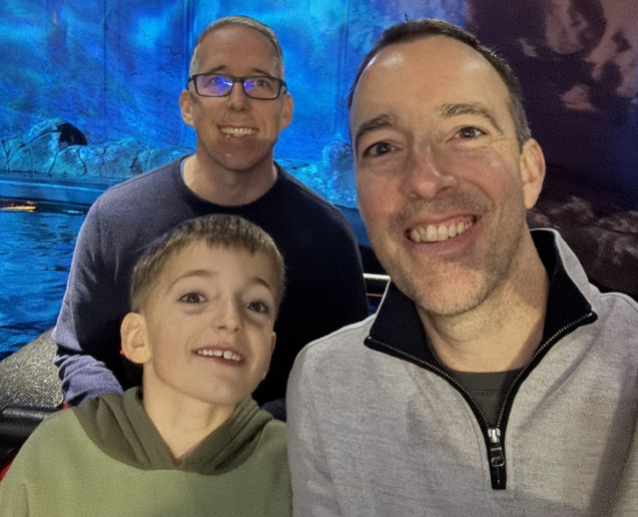
I am excited to stand for election as a Board Member at JOY Media. With over two decades of diverse professional experience in accounting, strategy, governance, and business advisory, I bring a strong foundation in supporting not-for-profit organisations to achieve sustainable growth and impact. My expertise includes strategic business planning, revenue diversification, finance transformation, and operational optimisation, enabling organisations I have worked with to strengthen their financial sustainability and achieve impactful outcomes.
I have extensive experience delivering outsourced accounting services, audit and assurance, and governance reviews that embed robust controls and risk management frameworks. As a trusted advisor and mentor, I am passionate about fostering high-performing teams and collaborating effectively with boards and senior management to align strategy with operational excellence.
I also bring a strong focus on digital innovation and change management, having led projects that modernise finance functions and drive culture optimisation, which are key to future-proofing organisations. What drives me most is working with purpose-driven organisations to realise their potential through practical, commercially focused solutions.
As part of a proud rainbow family, my husband and I have been blessed to welcome our son via surrogacy. We love seeing him growing up into a fun-loving and confident young child. This personal experience deepens my commitment to community, diversity, and inclusion—values that are core to JOY Media’s mission.
Family photo from recent trip to Sydney (I am at the front in the grey top).

JOY Media Board Candidate Statement 2025 – David Johnston-Bell

David is member 18, and was instrumental in bringing Joy to the air for its first test broadcasts and was on Joy's first board. David was also involved with Bent-TV and Midsumma.
David brings over 25 years of experience as a manager specialising in large-scale systems design, technology planning, and ICT governance. He holds a Master of Engineering from RMIT and an MBA from Deakin University, and he is also a graduate of the Australian Institute of Company Directors.
David’s career spans diverse industries, including broadcasting, disability, health, defence, retail and logistics, telecommunications, education, and automotive. This broad background allows him to share valuable insights into different ways of working, enhancing Joy's ability to deliver innovative broadcasting experiences.
David will bring to Joy his decades of experience to enable Joy to fulfil its potential for a world beyond terrestrial broadcasting.

